TENDERDOCUMENT No. HLL/CHO/HCS/HINDLABS/TENDER/2016-17/01
Dated 18/05/2016

HLL LIFECARE LIMITED,
(A Government of India Enterprise)



For the supply of Printed stationary items to HINDLABS Centers at Kerala

NOTICE
NOTICE INVITING TENDER FOR THE PRINTED STATIONARIES FOR HINDLABS, CENTERS, KERALA
The HLL Life care Limited (HLL), Trivandrum invites sealed competitive bids from reputed suppliers/agencies/ manufactures / firms for supply of printed stationary to HINDLABS CENTERS, The value of contract is approximately up to Rs.5 lakhs. (Rupees Five lakhs approximately)
Publishing date of bid :18-May-2016
Tender in the prescribed form duly filled in signed and stamped in sealed cover superscripted on it “TENDER FOR PRINTED STATIONARIES FOR HINDLABS I CENTERS” shall be addressed to AVP ( HCS),,HLL Lifecare Limited,HLL Bhavan, Poojappura,Thiruvananthapuram, Ph: 0471 – 2354949.
Last date of submission: 09 June 2016, 14.00 Hours.
AVP ( HCS),
HLL Life care Limited
HLL Bhavan, Poojappura
Thiruvananthapuram
Ph: 0471 – 2354949.

Opening of bid: 09 June 2016, 16.00 Hours.
HLL Life care Limited
HLL Bhavan, Poojappura
Thiruvananthapuram
Ph: 0471 – 2354949.

Applicants may obtain all the tender documents downloaded from HLL Website at www.lifecarehll.com.Tender form shall be forwarded along with the Bank Draft of EMD ofRs.10,000/- in favor of HLL Lifecare Ltd, payable at Trivandrum. Tender will be opened in presence of interested vendors.

HLL reserves the right to accept or reject any application without assigning any reason or incurring any liability whatsoever. Incomplete/Conditional tender without earnest money or received after due date and time shall be summarily rejected. Prospective bidders are advised to regularly scan through HLL web site as corrigendum/amendments etc, if any, will be notified on the HLL web site and separate advertisement will not be made for this regard.

SECTION – I

INFORMATIONANDINSTRUCTIONSTOTHE PARTICIPANTS

SCOPE OF WORK

- Printing and supply of stationary items to HINDLABS Centers Kottayam,Alappuzha,Thrissur ,Kozhikode and Trivandrum

TECHNICAL SPECIFICATION

Sample of the required items to be printed can be obtained from HLL Lifecare Limited,HLL Bhavan, Poojappura, Thiruvananthapuram. The paper quality of the material has to be as per the samples.

The specifications, Terms and Conditions for supply of Stationary items are as follows:-

Hindlabs Requirement details- Kottayam, Alappuzha, Thrissur, Kozhikode & Trivandrum
Items | Specification | HindlabsKottayam | HindlabsThrissur | Hindlabs Alappuzha | Hindlabs Kozhikode | Hindlabs trida Trivandrum | Hindlabs Trivandrum (MRI) | Hindlabs Trivandrum (CT)
Letter Head | A4 size Multi Colour One side Printing. 80 GSM. | 20,000 Nos | 12,000 Nos | 20,400 Nos | 15, 600 Nos | 10000 Nos | 10000Nos | 10000Nos
Referral Forms | A4 Size Booklet (with 15 numbers of 70 GSM paper)double side two colour printing. | 2000 Booklets | 1800 Booklets | 1800 Booklets | 1200 Booklets | N.A | 1000 Booklets | Na
Referral Forms (USG) | A4 Size Booklet (with 15 numbers of 70 GSM paper)double side two colour printing. | N.A | N.A | N.A | 1440 Booklets | N.A | Na | Na
Referal form CT | A4 Size Booklet (with 15 numbers of 70 GSM paper)double side two colour printing. | N.A | N.A | N.A | N.A | N.A | N.A | 1000Booklets
Visiting Card | One side Printing, Multi Colour, Size: 9cm x 5cm. | 500 Nos | N.A | 500 Nos | 1000 Nos | 3600 Nos | 5000Nos | 5000Nos
MRI Screening Forms | A4 Booklets containing 50 numbers of 70 GSM paper, double side one colour printing. | 200 Booklets | 240Booklets | 150 Booklets | 96 Booklets | N.A | 100Booklets | Na
CT Screening form | A4 Booklets containing 50 numbers of 70 GSM paper, double side one colour printing. | Na | Na | Na | Na | Na | Na | 100Booklets
Feedback form | A 5 size booklet containing 50 numbers of 70 GSM paper , double side one colour printing | 100 Booklets | 24 Booklets | 100 Booklets | 60 Booklets | 120 Booklets | 100Booklets | 100Booklets
Report Paper | A4 size, Executive, Front Multi Color, Back Side Single Color Printing, 80 GSM paper | N.A | N.A | N.A | N.A | 60000 Nos | Na | Na
Prescription pad | Double side, Two Color Printing, Size: A4, Booklet of 15 pages, 70 GSM paper | N.A | N.A | N.A | N.A | 1800 booklet | Na | Na
Bill Paper | A 5 size Multi Color One Side Printing,70 GSM paper | N.A | N.A | N.A | N.A | 50000 | Na | Na
Envelope 10.5 x 4.5 inches | 10.5 x 4.5 inches | 500 Nos | N.A | 400 Nos | 480 Nos | 60, 000 Nos | 500 Nos | 500 Nos
Envelope (A4 sized) | (10.5 x 8) Inches | 200Nos | 600 Nos | 400 Nos | 480 Nos | N.A | 200 Nos | 200 Nos
Envelope | One side Single Color Printing 12X9.5 inches | N.A | N.A | N.A | N.A | 2000 Nos | Na | Na

Interested applicants may supply all the items as per Annexure-1

- Softcopies of the forms will be provided on request.
- Samples of the same can be collected HLL Life care Limited, HLL Bhavan, Poojappura, Thiruvananthapuram, Ph: 0471 – 2354949.

ESTIMATED COST OF THE SUPPLY: Rupees Five lakh approximately.

Earnest Money Deposit: Tender form shall be forwarded along with the Bank Draft of EMD of Rs 10,000/- (Rs. Ten thousand only) in favor of HLL Life care Ltd. payable at Trivandrum. Bids submitted without EMD will be rejected. The EMD of the successful bidder will be refunded at the end of the contract period. EMD of the unsuccessful bidders will be repaid within 30 days on completion of the tender formalities.

DELIEVERY: The delivery will be made at HINDLABS, Kottayam, Alappuzha, Thrissur Kozhikode and Trivandrum on indent basis. The supplier can quote minimum quantity required for each consignment/intent. Cartage/coolliage shall have to be borne by the Tenderer. The material should be supplied as per the time limit given in the order.

PENALTY CLAUSE: A penalty @ 4% per week subject to maximum of 10% on the delayed supply will be imposed in case of supply is not made in accordance with the time schedule given by HLL in the work order.

PRICES: The prices to be quoted as per Annexure-2. Quoted prices shall be valid for a period of one year.

CONTRACT TERMINATION: HLL Life care Limited reserves the right to terminate the contract at any time without any notice and forfeit part or whole of the earnest money of the tender if tenderer fails to make the supply within the prescribed period or the supply is not found in accordance with the specification or not in the quality/quantity as per the orders placed or there is any breach of the terms of the contract on the part of tenderer. The earnest money will be forfeited, if the tenderer, after approval of the tender fails to accept it.

Eligibility:

- The firm should have minimum three years’ experience for supply of printed stationary with similar institutions / scanning centers, documentary evidences for the same have to be attached. The scrutiny committee will have the right to reject the tender of the firm who have not submitted the required documents.

- The firm should have minimum annual turnover of Rs 10,00,000.00(Rupees Ten Lakhs only)

- The firm should have handled order of Minimum 60% of total order value of estimated cost of supply. Documentary proof may be submitted in this regard.

- Even though the applicants satisfy the above requirements they may be disqualified ,if they have:

A Made misleading or false representation of facts or deliberately suppressed the information to be provided in the forms, statements and enclosures of this document.

b) Previous history of poor performance such as abandoning work, not properly completing the contract or financial failure/weaknesses.

Quality Inspection: The quality inspection will be done by the HINDLABS team, by taking random samples from the supply made, for quality of the items as per specification. Any difference in size, weight, color etc will render the entire order for rejection and the tenderer shall have to lift the material at their own cost on “as is where basis is”. In case of any dispute, decision by HLL will be final and irrevocable.

Order placement: The supply order shall be placed on the lowest responsive bidder. The revision of rates will not be allowed during the contract period of one year.

Payment: The Payment shall be made after a credit period of 60 days from the date of receipt of materials as per PO at our site. For claiming the payment, the following documents have to be submitted.
- Three copies of invoices
- Delivery receipt duly signed by the concerned person of HLL and representatives of the supplier.

Guidelines
- If the bid opening day is declared as holiday for HLL, the bid will be opened the next working day. Bidders can come and attend the bid opening on due date.
- Interested applicants can participate in the bid.
- Any bid received after the deadline for submission of bids will be rejected. HLL shall not be liable for the delay in submission of bids after due date specified above due to any reason including postal delay.
- No Email or fax bids will be accepted.
- The name and mailing address of the Applicant should be clearly marked on the envelope.
- All the information asked in this document shall be answered in the ENGLISH language only.
- Failure to provide information in the stipulated format enclosed or to provide timely clarification or substantiation of the information supplied (considered essential to evaluate the Applicant’s qualification) may result in disqualification of the Applicant.
- Extension of contract

The contract may be extended for one/two years, if the work is found satisfactory on the same rates/terms and conditions.

All the above stated terms and conditions should be acceptable to the bidder.
All the bids shall remain valid for one year from the date of opening of bids prescribed by HLL. A bid valid for a shorter period shall be rejected by the HLL being non-respective.

GENERAL INFORMATION

  - The applicant’s name, signature and Firm’s stamp should appear on each page of the application.

  - Overwriting should be avoided. Neatly crossing out, initiating, dating and rewriting shall make correction(s), if any .All pages of tender documents shall be numbered and submitted as a package with signed and stamped letter of transmittal.

  - A senior officer of the client should sign references, information and certificates from the respective clients certifying suitability, know-how and capability of the applicant.

  - The applicant is advised to attach any additional information, which he thinks is necessary in regard to his capabilities to establish that the applicant is capable in all respects. He is however, advised not to attach superfluous information. No further information will be entertained after tender document is submitted, unless the organization calls it for.
  - Prospective applicants may seek clarification regarding the scope, and/or the requirements within two working days. No request for clarification will be considered after receiving the pre-qualification tenders.

TENDERSUBMISSION AND AWARD

  - The tender will be evaluated based on documents submitted meeting all the minimum eligibility criteria and the prices quoted. Work will be awarded to the vendor who satisfies all the minimum eligibility requirements and also quoted the lowest price for each item.
  - The HLL reserves the right to:

    - Amend the scope and value of contract.

    - Reject any or all the bids without assigning any reason.

    - For any of the above actions, the organization shall neither be liable for any damages, nor be under any obligation to inform the applicants of the grounds for the same.

    - Effort on the part of the bidder or his agent to exercise influence or to pressurize the organization for his bid shall result in rejection of such bid.

    - Canvassing of any kind is strictly prohibited.

OTHER INFORMATION TO BE SUBMITTED ALONGWITH APPLICATION

  - Registration/ License: The Applicant should furnish CST/VAT Registration number with the bid.

  - If any information furnished by the applicant is found incorrect at a later stage, applicant shall be liable to be debarred from tendering in HLL. The Company reserves the right to verify the particulars furnished by the applicant independently.

  - HLL may ask for any additional information and/ or clarification from the applicant. The applicant shall submit such additional information and/ or clarification as requested by HLL within the time specified in the communication.

  - The competent authority to pre-qualify shall have the power to relax any condition/criterion for pre-qualification if it considers expedient to do so.

  - Even though the agency meets all the criteria, the HLL reserves the right to accept or reject any applicant/disqualify any agency without assigning any reason whatsoever

  - The HLL reserve the right to:

    - Reject or accept any application without assigning any reason or incurring any liability

    - Cancel the pre-qualification process and reject all applications

    - Split the works into different packages if required

    - Amend the scope and value of any contract under this project, in such event the bids will only be called from those pre-qualified applicants who meet the requirements of the contract as amended.

    - No correspondence either from successful / pre-qualified applicant or unsuccessful applicant will be entertained in this regard.
Sample formats are attached as Annexure-3

For and On Behalf Of HLL Life Care Limited

AVP (HCS)

ANNEXURE-1

ADDITIONAL INFORMATION OF VENDORS

(General information of the manufacturer / supplier)
1. Name & Address of the Supplier :
a) Telephone No. :
b) Fax No. :
c) Mobile No. :
d) E-mail Address :
e) Website :
f) Name of contact person :
g) Whether proprietary/partnership/
Limited company :
h) Specify whether SSI / MSME unit :
2. How many years have you been in the
Business of manufacturing /selling? :
3. Have you been a supplier to any
Public sector/ Government Lab or any major pvt hospitals/
Leading Retailers(during the last 3 years)
If so give details of five firm’s Name, address,
And quantity
6. Details of tax registration :
a) CST No. :
b) TIN No. and VAT No. :
c) PAN No. :

8. Bank Information
a) Bank Name :
b) City :
c) Branch Name :
d) Branch Code :
e) Account No. :
f) Account Type :
g) IFSC Code (Issued by RBI to Bank) :
All the information provided herein is true & correct.

Date: NAME & SIGNATURE OF THE APPLICANT
(WITH OFFICE SEAL)

PLACE:

ANNEXURE 2 - PRICE BID

Sl. No | Description of Item | Quality/Specs | UNIT | QUANTITY | Basic price | Taxes/  Duties etc | Other incidental cost | Total Price for each unit(Rs) | Amount(Rs)
1 | Letter Head | A4 size Multi Colour One side Printing. 80 GSM. | Nos | 98000
2 | Referral Forms | A4 Size Booklet (with 15 numbers of 70 GSM paper)double side two colour printing. | 1 Booklet with 15 pages | 7800
3 | Referral Forms (USG) | A4 Size Booklet (with 15 numbers of 70 GSM paper)double side two colour printing. | 1 Booklet with 15 pages | 1440
4 | Referal form CT | A4 Size Booklet (with 15 numbers of 70 GSM paper)double side two colour printing. | 1 Booklet with 15 pages | 1000
5 | Visiting Card | One side Printing, Multi Colour, Size: 9cm x 5cm. | Nos | 15600
6 | MRI Screening Forms | A4 Booklets containing 50 numbers of 70 GSM paper, double side one colour printing. | 1 Booklet with 50 pages | 786
7 | CT Screening form | A4 Booklets containing 50 numbers of 70 GSM paper, double side one colour printing. | 1 Booklet with 50 pages | 100
8 | Feedback form | A 5 size booklet containing 50 numbers of 70 GSM paper , double side one colour printing | 1 Booklet with 50 pages | 604
9 | Report Paper | A4 size, Executive, Front Multi Color, Back Side Single Color Printing, 80 GSM paper | Nos | 60000
10 | Prescription pad | Double side, Two Color Printing, Size: A4, Booklet of 15 pages, 70 GSM paper | 1 Booklet with 15 pages | 1800
11 | Bill Paper | A 5 size Multi Color One Side Printing,70 GSM paper | Nos | 50000
12 | Envelope 10.5 x 4.5 inches | 10.5 x 4.5 inches | Nos | 8350
13 | Envelope (A4 sized) | (10.5 x 8) Inches | Nos | 2080
14 | Envelope | One side Single Color Printing 12X9.5 inches | Nos | 2000
Total Price in Figures:___________________________________________
Total Price in words____________________________________________
Minimum quantity required for each consignment/intent.
Sl.No | Item | Minimum quantity required for each consignment/intent.

Date : Signature of the Applicant
Place : (With Seal)

Annexure - 3
Envelope:
Thrissur
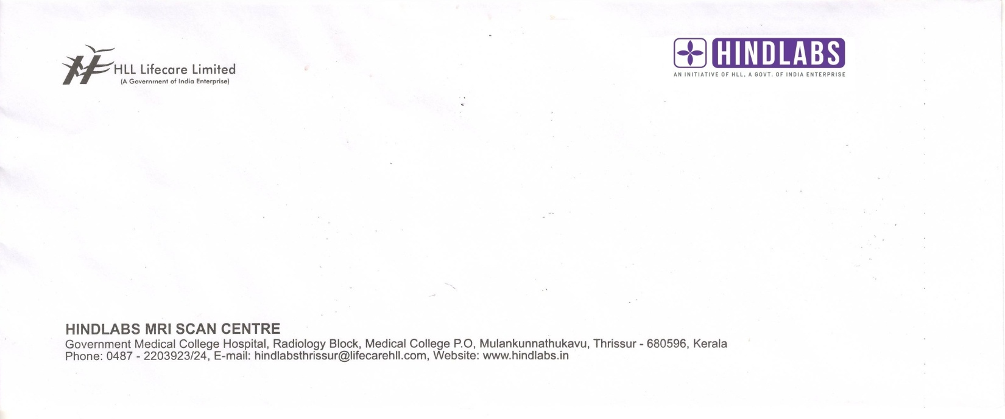

Alapuzha
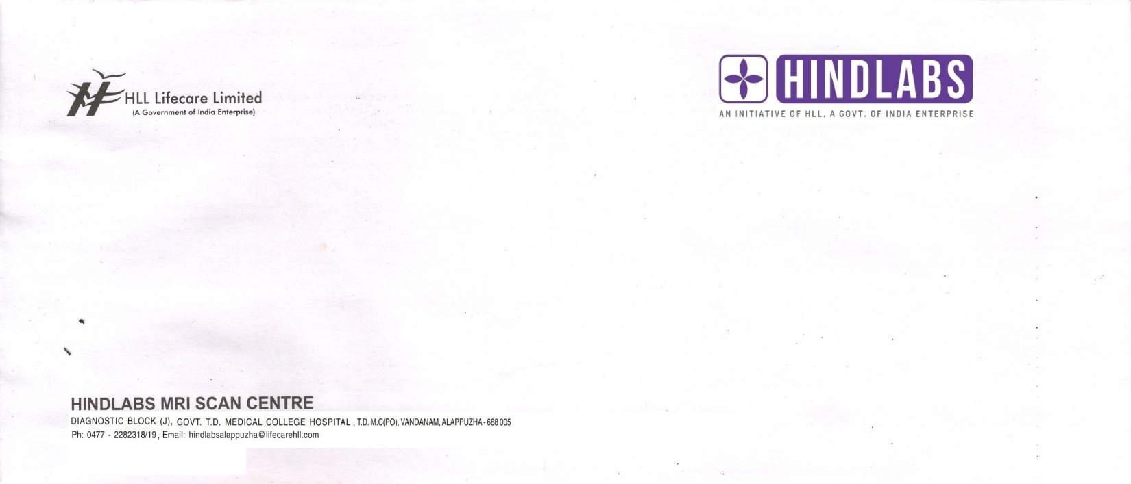

Calicut
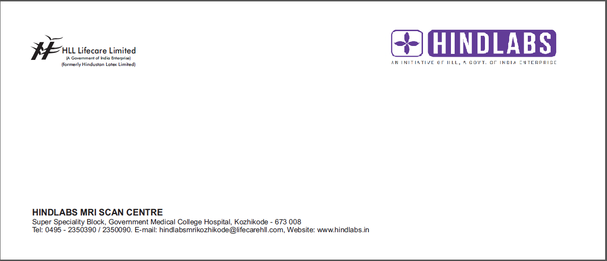

Kottayam
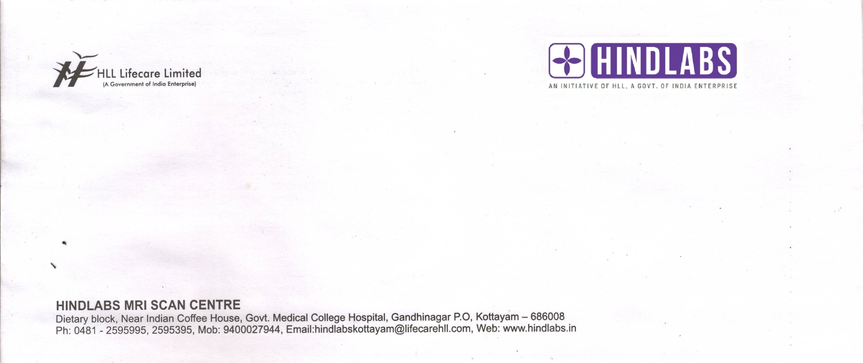

Feedback form:

All centres
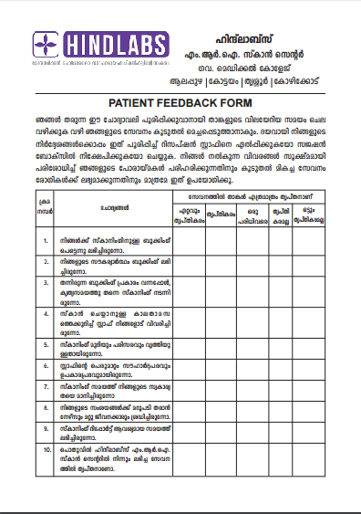

Referral form:
Kottayam
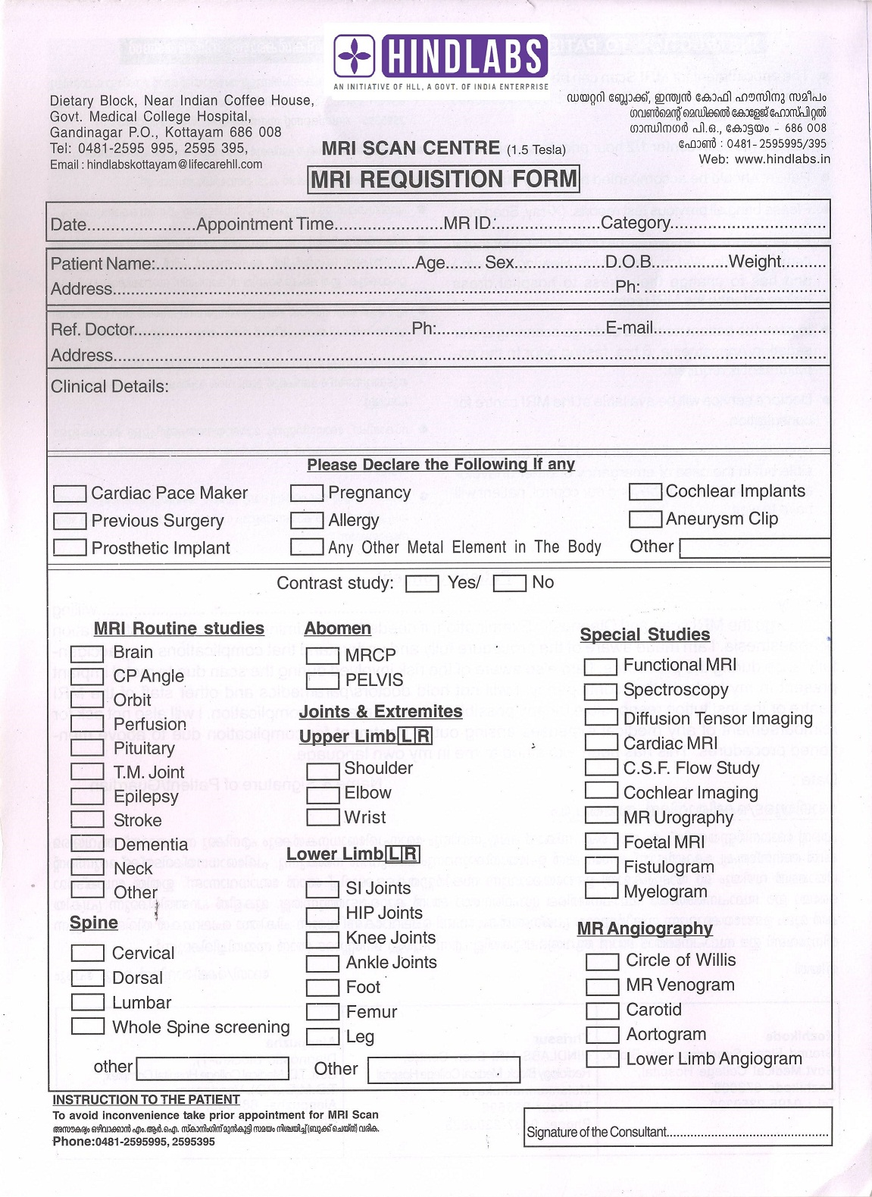
Alapuzha
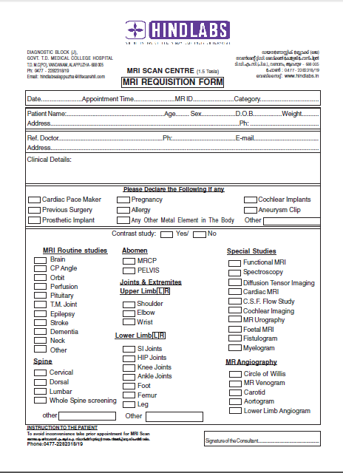
Thrissur

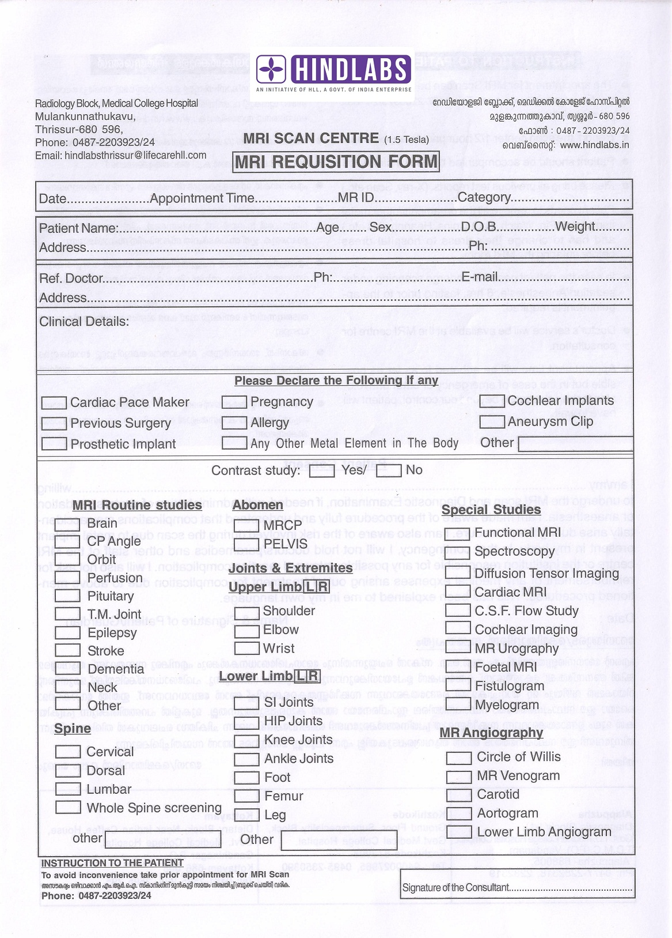

Calicut MRI

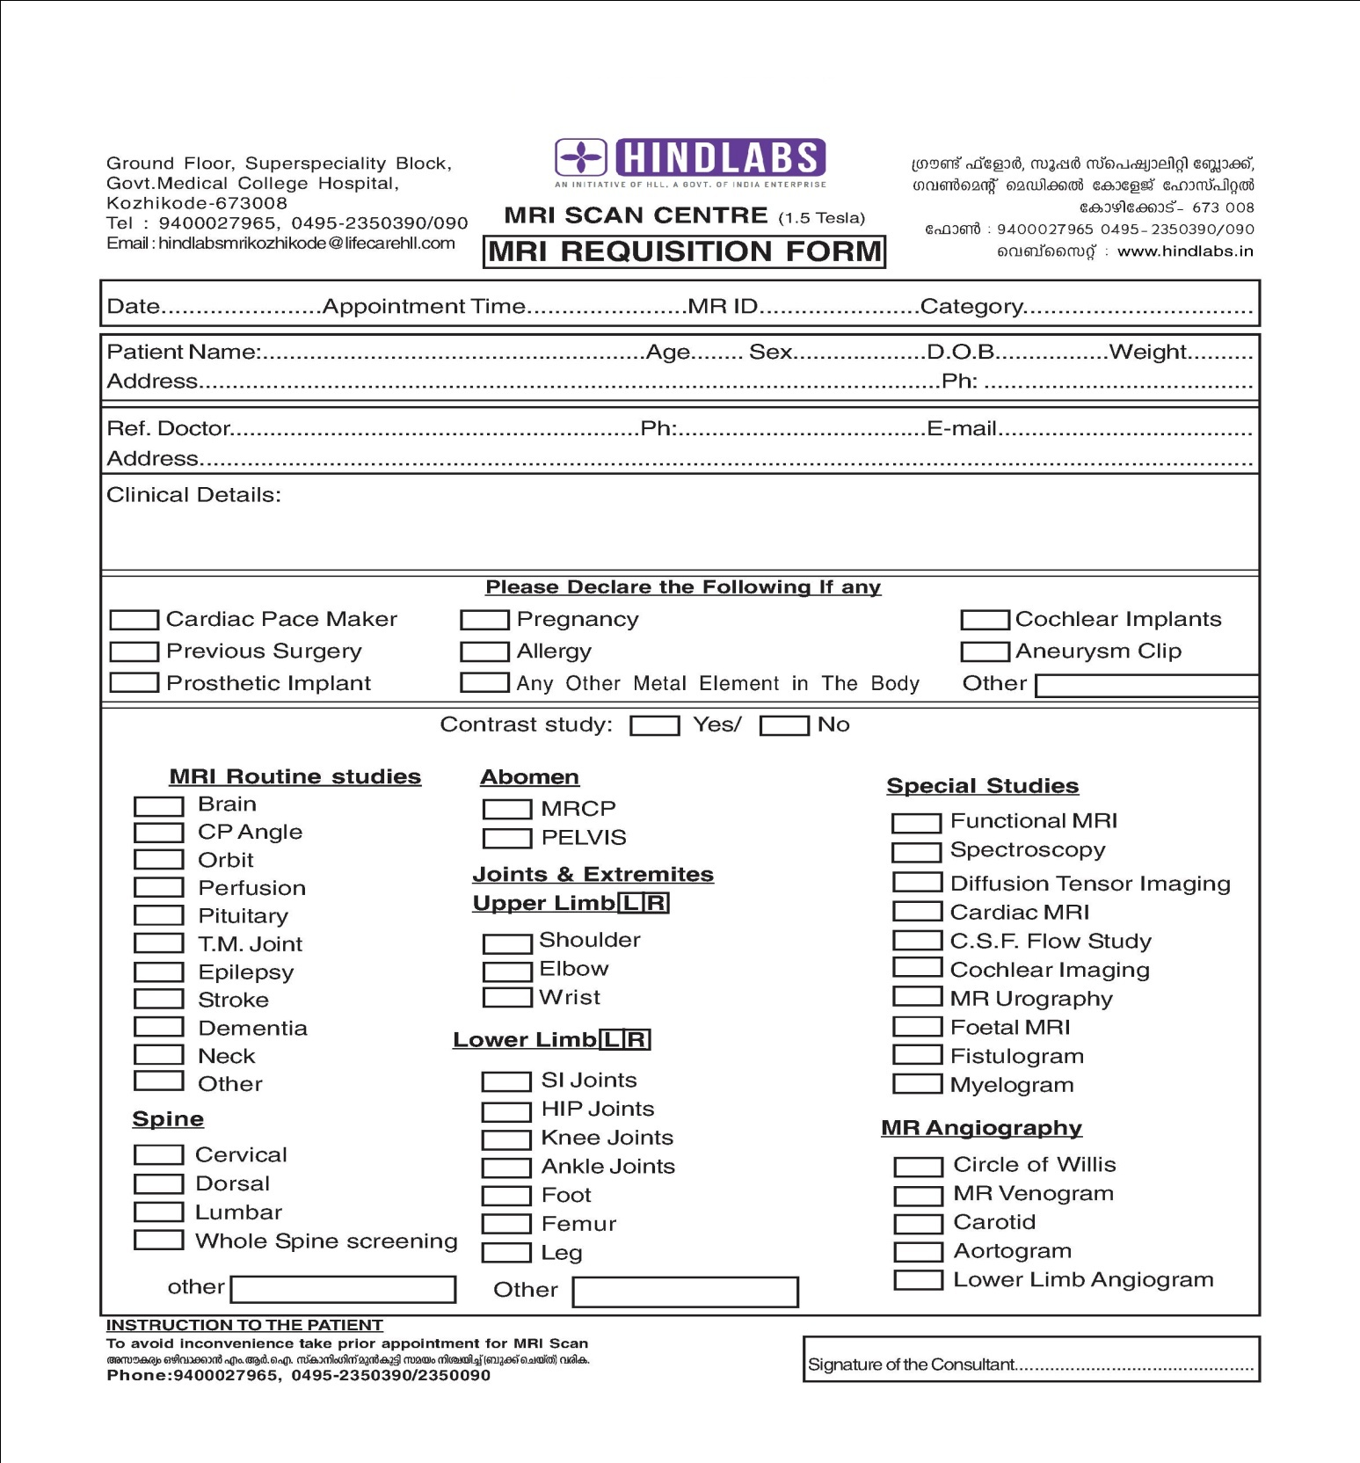

Calicut USG


USG REQUISITION FORM
4D–ULTRASOUND& 1.5 T MRI SCAN
Ground Floor, Superspeciality Block ഗ്രൗണ്ട്ഫ്ലോര്‍, സൂപ്പര്‍സ്പെഷ്യാലിറ്റി ബ്ലോക്ക്‌
Govt.Medical College, Kozhikode ഗവണ്‍മെന്‍റ് മെഡിക്കല്‍കോളേജ് ഹോസ്പിറ്റല്‍
Mob: 9400027965 കോഴിക്കോട്.Ph: 0495-2350390/ 2350090
Date……………………..Appointment Time……………………………..ID……………………Category………………..

Patient Name………………………………………………..Age…………Sex………….Phone………………………………
Address……………………………………………………………………………………………………………………………………….
Referring Doctor Name…………………………….Department………………………..Phone…………………………
Clinical Details:
UPPER ABDOMEN  □Gall bladder  □Biliary tract  □Pancreas  □Liver  □Spleen  □ Kidney  □Large blood vessels  □ AORTA  RENAL TRACT  □Kidney  □Urinary bladder  USG GUIDED PROCEDURES  □ FNAC  □BIOPSY□NEPHROSTOMY | OBSTETRICS & GYNAECOLOGY  □ TV Scan  □ Pelvis  □Pregnancy scan  □ Anomaly scan  NEONATAL ULTRASOUND  □ Cranium  □ Renal  □ Abdomen  MSK PROTOCOL  □Hips  □Shoulder  □Elbow | DOPPLER STUDY  □Arterial Bilateral  □Arterial each limb  □Carotid  □Obstetric Doppler  □Renal  □TVS Pelvis  □Venous bilateral  □Venous each limb  □SCROTUM  SMALL PARTS  □Breast  □Thyroid
  OTHERS

രോഗികള്‍ക്കുള്ള നിര്‍ദേശങ്ങള്‍:1) വയറിന്‍റെ സ്കാന്‍ ചെയ്യാനുള്ളവര്‍ സ്കാന്‍ ചെയ്യുന്നതിന് 6 മണിക്കൂര്‍ മുന്‍പ് ഭക്ഷണo ഒഴിവാക്കുക. 2) സ്കാനിങ്ങിനു മുന്‍പ് ധാരാളം വെള്ളം കുടിച്ച് ബ്ലാഡര്‍ നിറയ്ക്കുക
Trivandrum USG

USG REQUISITION FORM

Hindlabs Diagnostic Centre & Polyclinic ഹിന്ദ്‌ലാബ്സ് ഡയഗനോസ്റ്റിക് സെന്‍റെര്‍ & പോളിക്ലിനിക്
Oppo. Govt.Medical College Hospital Oppo.ഗവണ്‍മെന്‍റ് മെഡിക്കല്‍കോളേജ് ഹോസ്പിറ്റല്‍
Thiruvananthapuram തിരുവനന്തപുരം.
Date……………………..Appointment Time……………………………..ID……………………Category………………..

Patient Name………………………………………………..Age…………Sex………….Phone………………………………
Address……………………………………………………………………………………………………………………………………….
Referring Doctor Name…………………………….Department………………………..Phone…………………………
Clinical Details:
UPPER ABDOMEN  □Gall bladder  □Biliary tract  □Pancreas  □Liver  □Spleen  □ Kidney  □Large blood vessels  □ AORTA  RENAL TRACT  □Kidney  □Urinary bladder  USG GUIDED PROCEDURES  □ FNAC  □BIOPSY□NEPHROSTOMY | OBSTETRICS & GYNAECOLOGY  □ TV Scan  □ Pelvis  □Pregnancy scan  □ Anomaly scan  NEONATAL ULTRASOUND  □ Cranium  □ Renal  □ Abdomen  MSK PROTOCOL  □Hips  □Shoulder  □Elbow | DOPPLER STUDY  □Arterial Bilateral  □Arterial each limb  □Carotid  □Obstetric Doppler  □Renal  □TVS Pelvis  □Venous bilateral  □Venous each limb  □SCROTUM  SMALL PARTS  □Breast  □Thyroid
  OTHERS

രോഗികള്‍ക്കുള്ള നിര്‍ദേശങ്ങള്‍:1) വയറിന്‍റെ സ്കാന്‍ ചെയ്യാനുള്ളവര്‍ സ്കാന്‍ ചെയ്യുന്നതിന് 6 മണിക്കൂര്‍ മുന്‍പ് ഭക്ഷണo ഒഴിവാക്കുക. 2) സ്കാനിങ്ങിനു മുന്‍പ് ധാരാളം വെള്ളം കുടിച്ച് ബ്ലാഡര്‍ നിറയ്ക്കുക
Trivandrum CT
ഹിന്ദ്‌ലാബ്സ് സി.റ്റി. സ്കാന്‍ സെന്‍റര്‍
ഗവ.മെഡിക്കല്‍കോളേജ് ആശുപത്രി
തിരുവനന്തപുരം
CT REQUEST FORM
Patient's Name: |  |  |  |  |  |  | Patient's Contact No:
Age: Gender |  |  |  | M | F
Doctor's Name: |  |  |  |  |  |  | Doctor's Contact No:
Clinical Details:
 |  | Plain |  |  |  |  | Contrast
HEAD AND NECK
 |  | Brain |  |  |  |  | CV Junction |  |  |  | Perfusion
 |  | Orbit |  |  |  |  | PNS |  |  |  | 3D face
 |  | Sella |  |  |  |  | IAS |  |  |  | Neck
 |  | Temporal Bone |  |  |  |  | Cisternogram
BODY
 |  | Chest |  |  |  |  | Lower Abdomen/Pelvis
 |  | Whole Abdomen |  |  |  |  | Virtual Bronchoscopy
 |  | Upper Abdomen |  |  |  |  | Chest and Upper Abdomen
SPINE
 |  | Cervical Spine |  |  |  |  | Dorsal Spine
 |  | Sacrum |  |  |  |  | Whole Spine
 |  | Lumbar Spine
MUSCULO SKELETAL
 |  | Shoulder |  |  |  |  | Wrist |  |  |  | Knee
 |  | Elbow |  |  |  |  | Hip |  |  |  | Ankle
 |  | TMJ |  |  |  |  | Thigh |  |  |  | Leg
 |  | Forearm |  |  |  |  | Foot |  |  |  | Toe
 |  | Sacro- illiac |  |  |  |  | Bony Pelvis |  |  |  | Arm
 |  | hand |  |  |  |  | Sterno Clavicular Joints
 |  | LEFT |  |  |  |  | RIGHT |  |  |  | BOTH
OTHER ANGIOS
 |  | Head and Neck |  |  |  |  | Abdominal
 |  | Cerebral Angio |  |  |  |  | Abdominal Aorta
 |  | Neck Angio (carotid and Vertebral) |  |  |  |  | Thoraco-Abdominal Aorta
 |  | Peripheral Angio |  |  |  |  | Celiac, Hepatic and SMA
 |  | Upper Limbs |  |  |  |  | IVC and Hepatic Veins
 |  | Lower Limbs |  |  |  |  | Splenoportovenogram
 |  | Thoracic |  |  |  |  | Renal Donor Evaluation
 |  | Thoracic Aorta |  |  |  |  | Renal Stenosis Evaluation
 |  | Pulmonary Arteries/Veins
Screening form:
All Centres
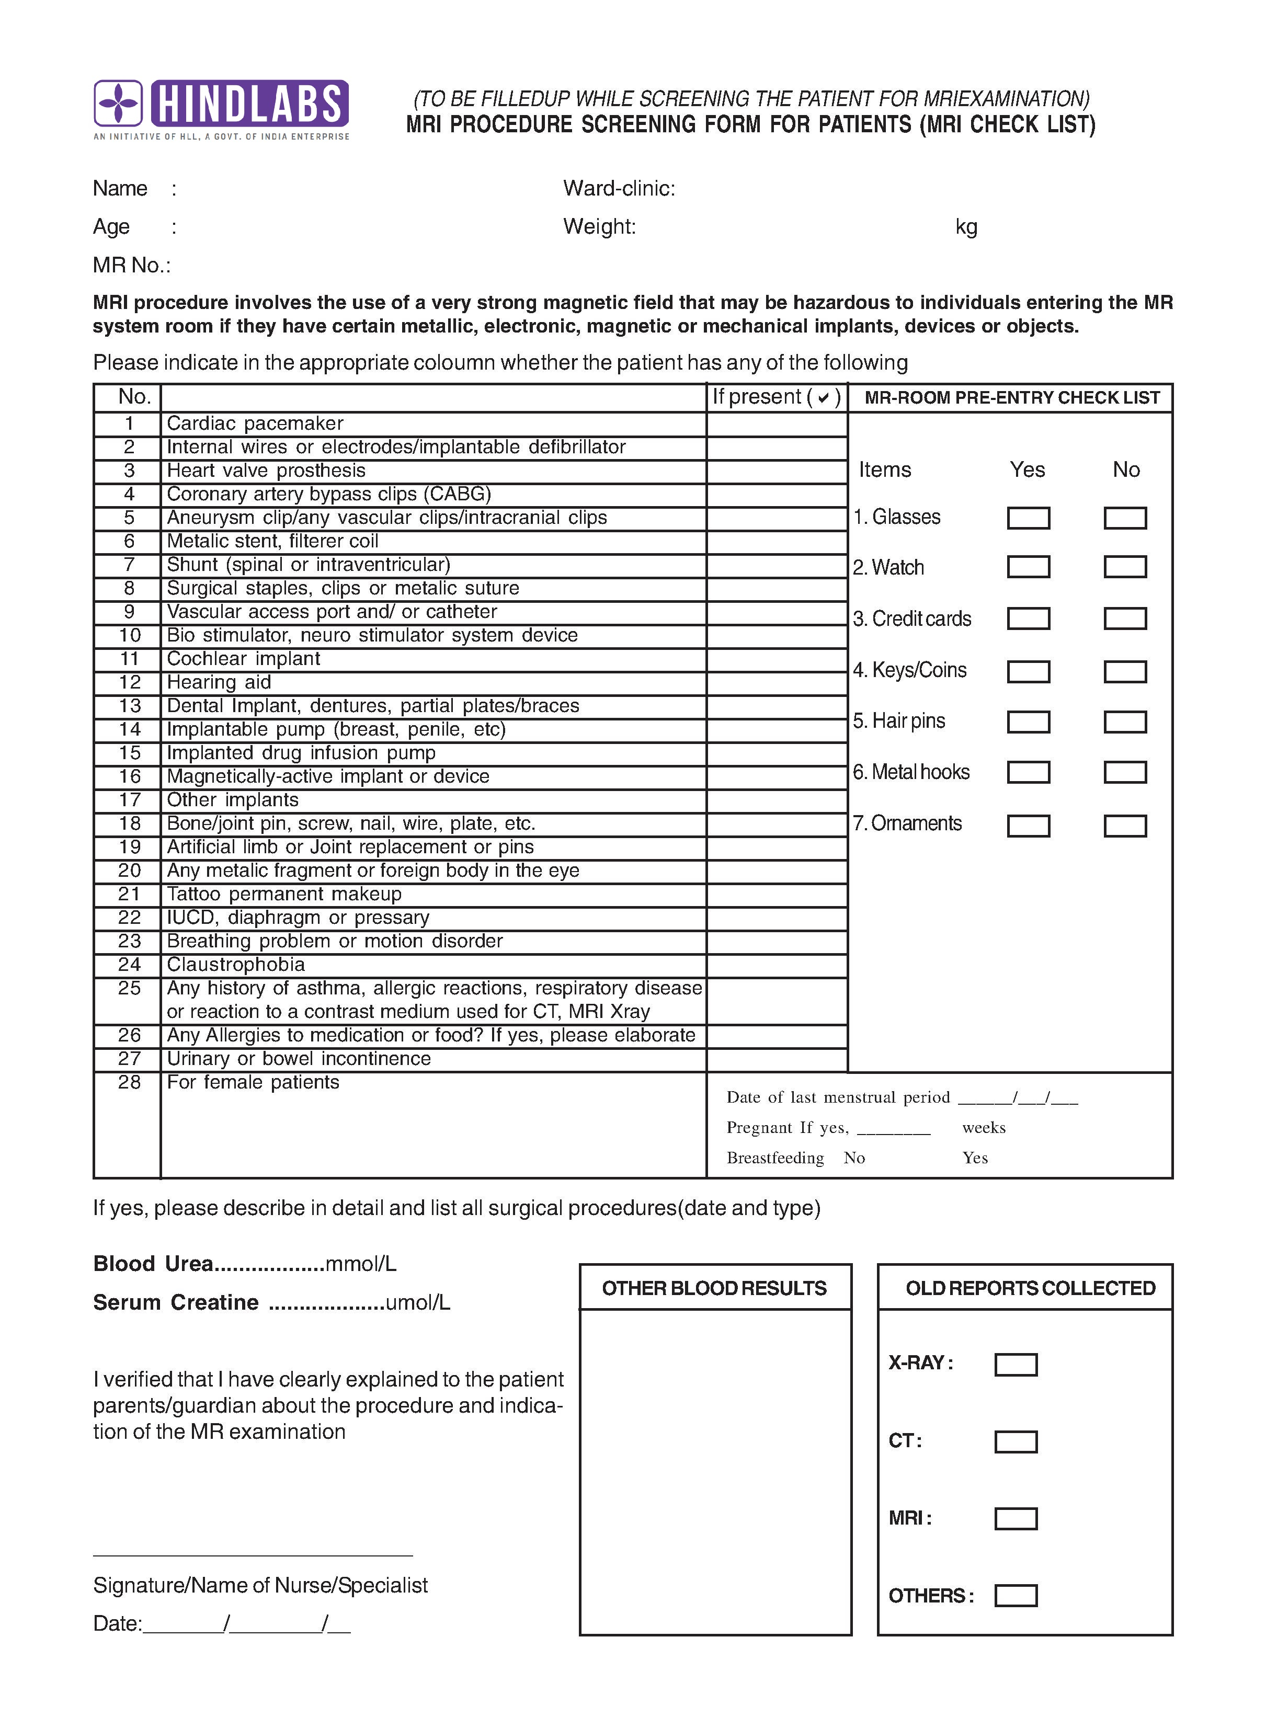

\

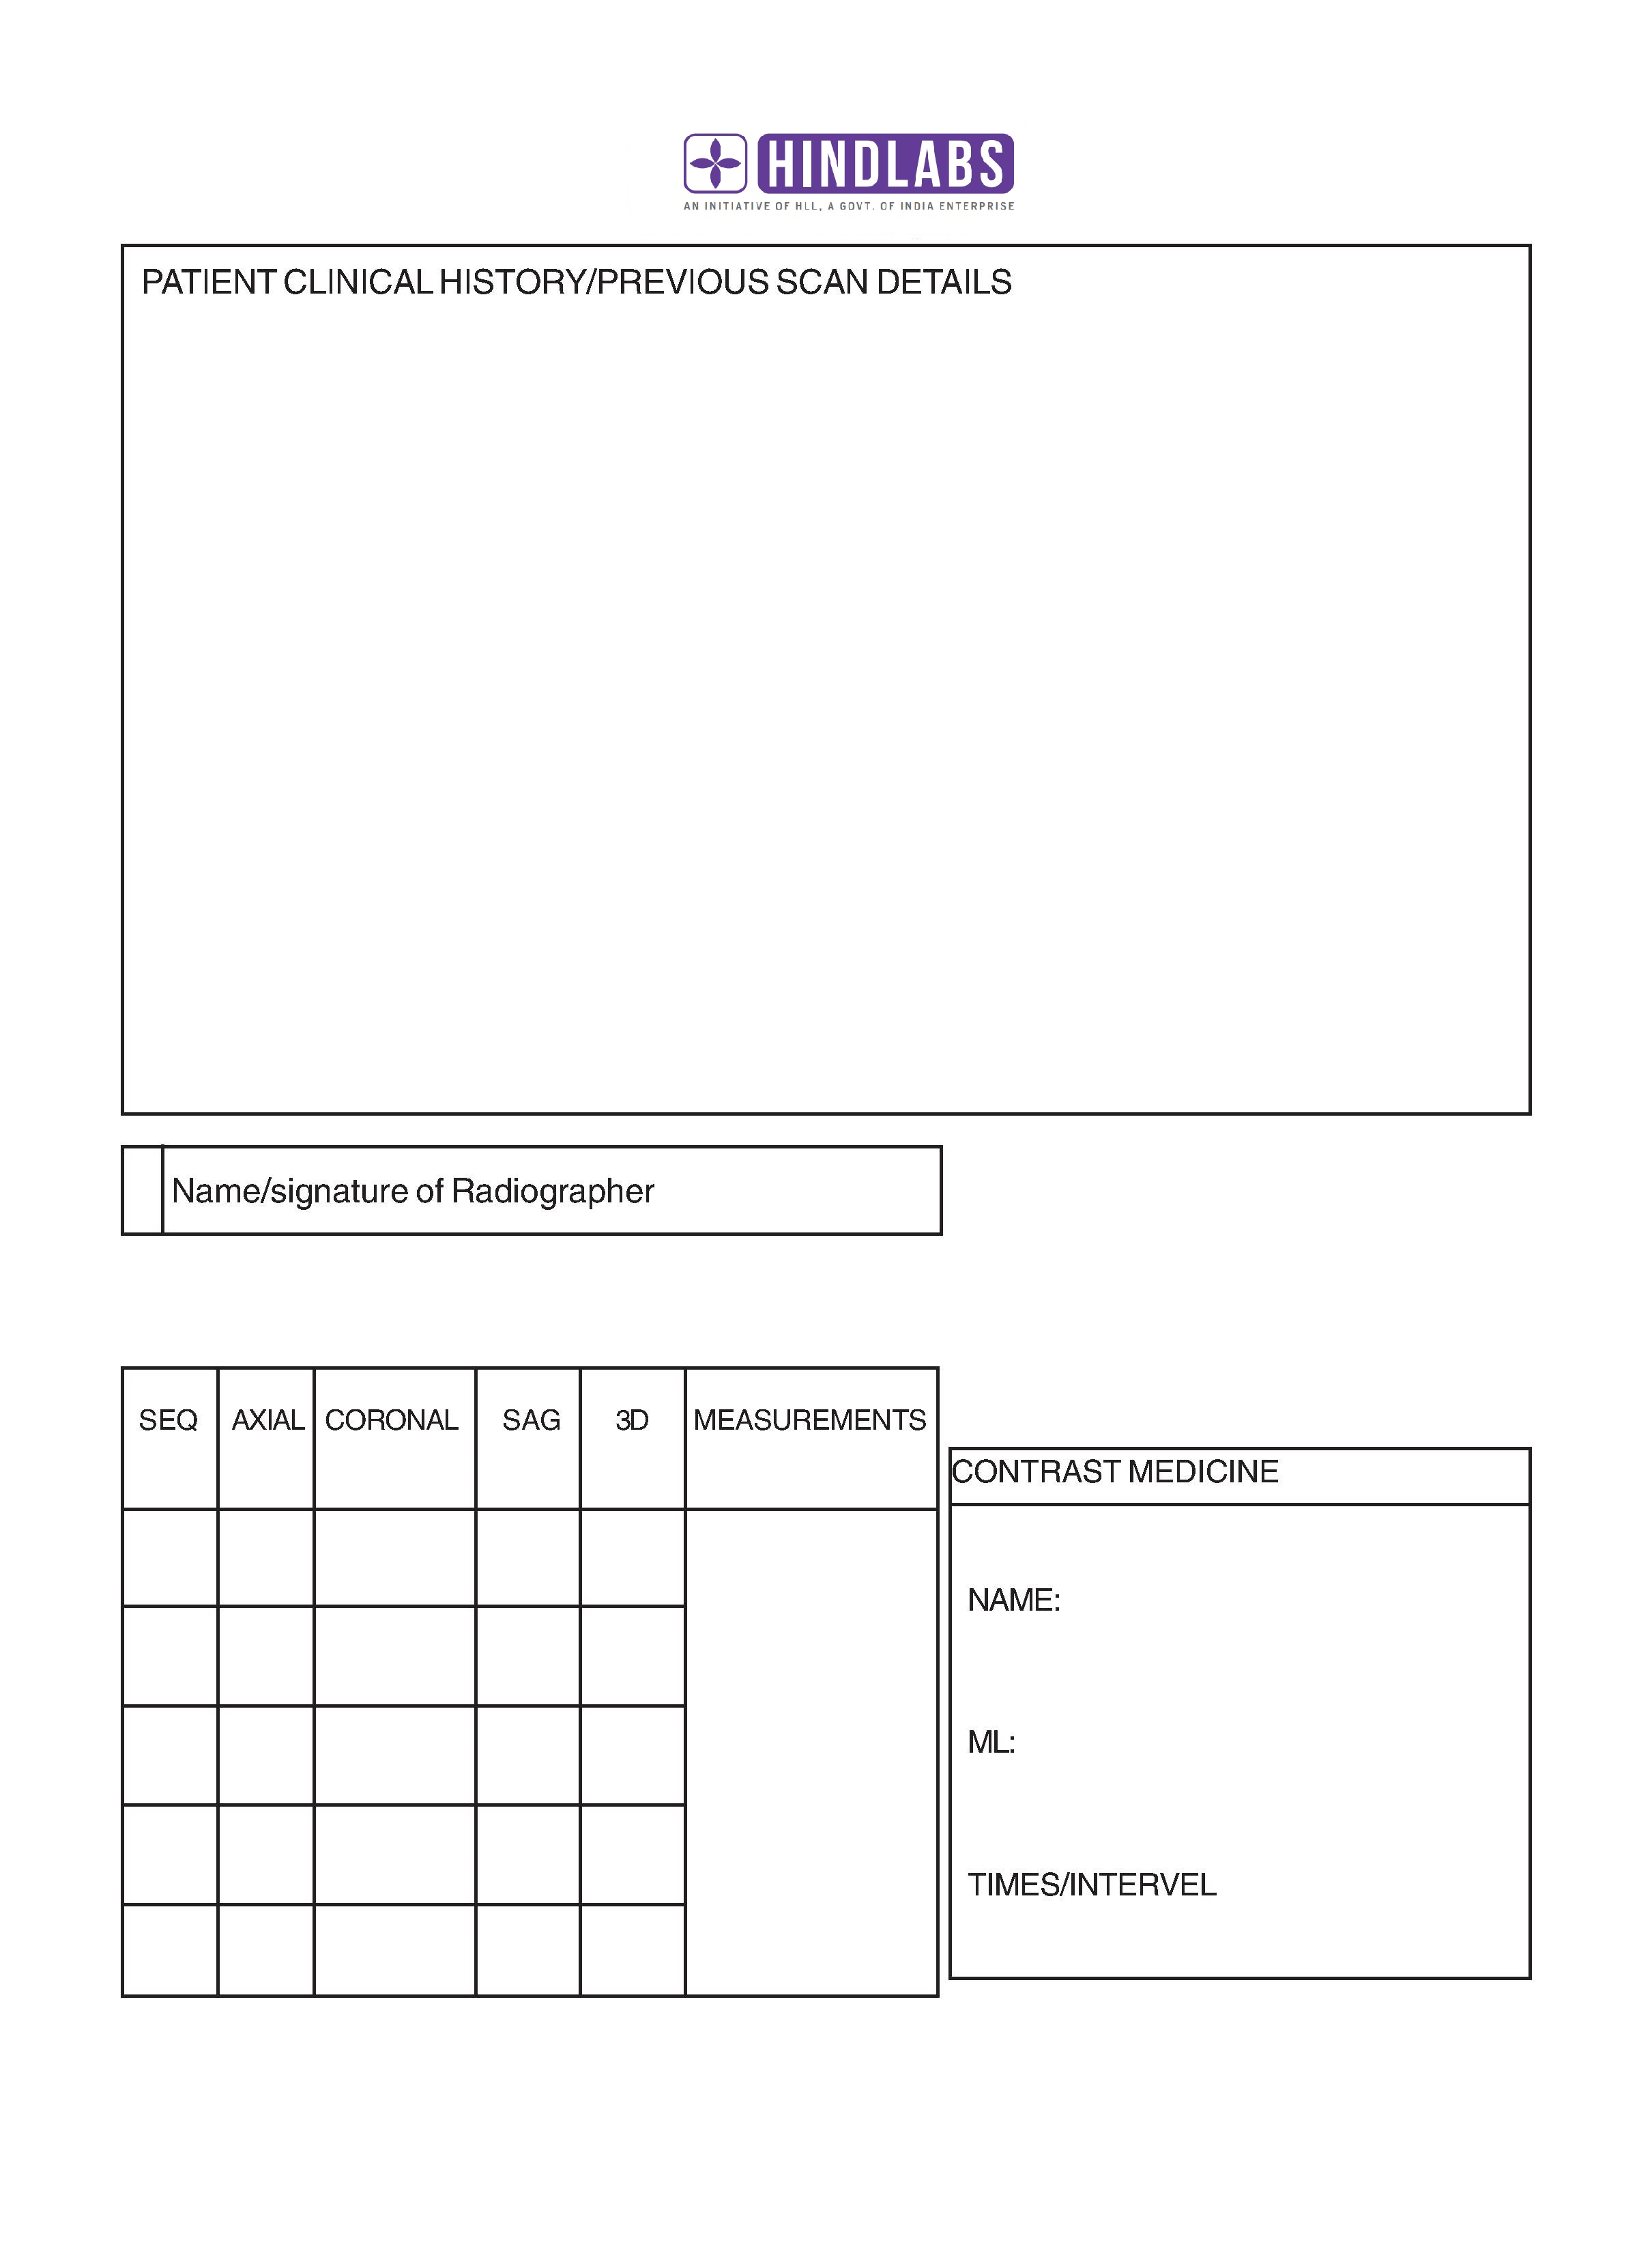

Trivandrum Diagnostics and Polyclinic Centre, Trida
ഹിന്ദ്‌ലാബ്സ് ഡയഗനോസ്റ്റിക് സെന്‍റെര്‍ & പോളിക്ലിനിക്
ഗവണ്‍മെന്‍റ് മെഡിക്കല്‍കോളേജ് ഹോസ്പിറ്റല്‍ എതിര്‍വശം
ട്രിഡ സോപാനം കോംപ്ലക്സ്, തിരുവനന്തപുരം.
പിന്‍കോഡ്: 695011, ഫോണ്‍: 0471 – 2443445, 2443446, 9400027969

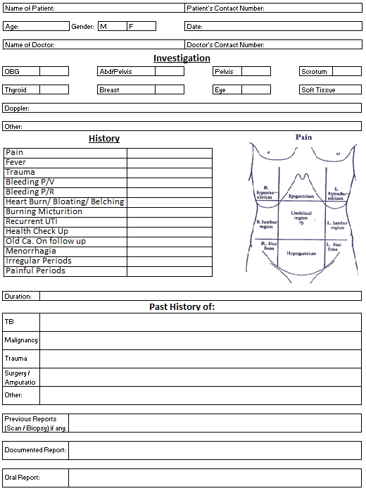
സ്ക്രീനിംഗ് ഫോം
രോഗനിര്‍ണ്ണയത്തിന് ആവശ്യമെങ്കില്‍ ഉള്ളിലൂടെയുള്ള (Trans Vaginal Scanning) സ്കാനിങ്ങിനു എനിക്ക് പൂര്‍ണ്ണസമ്മതമാണ്. ഇതിനെക്കുറിച്ച് സ്കാനിംഗ് അധികൃതര്‍ എന്നെ ബോധവതിയാക്കിയിട്ടുണ്ട്.

ഒപ്പ്:

Letter head:
Kottayam
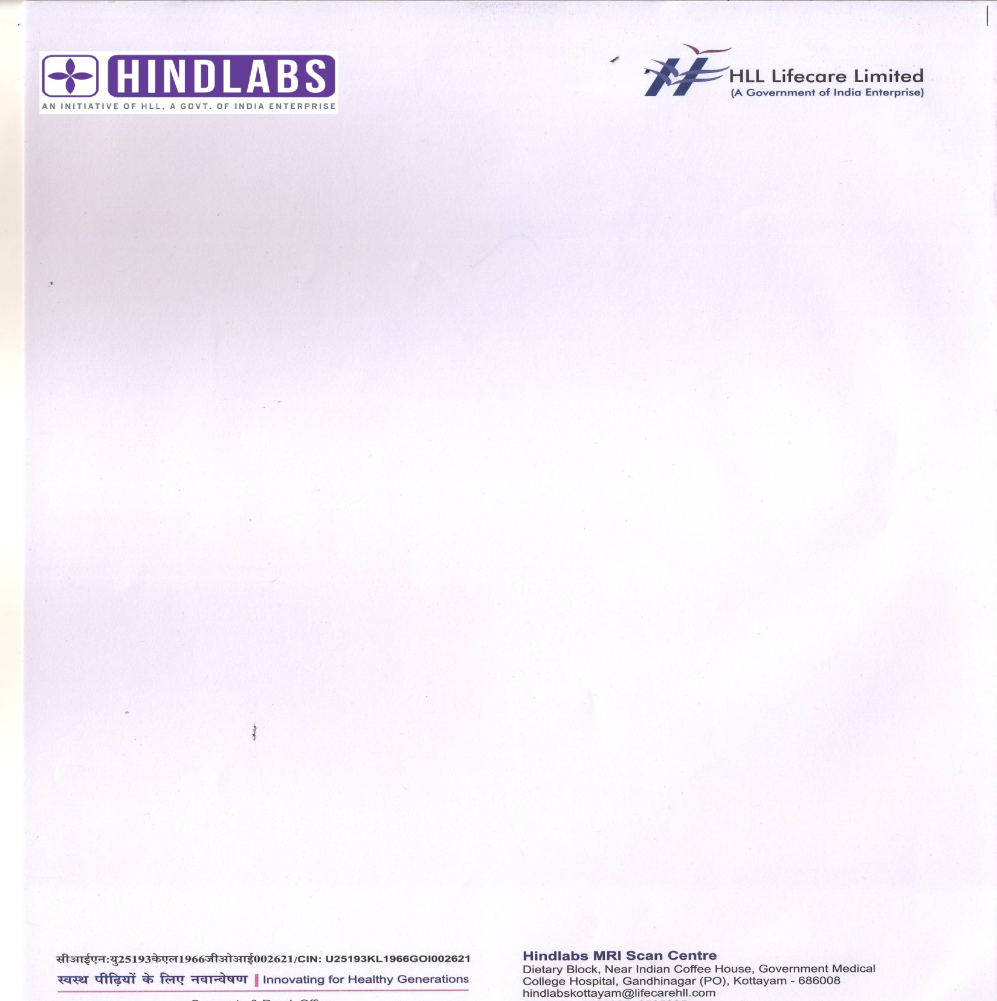

Thrissur
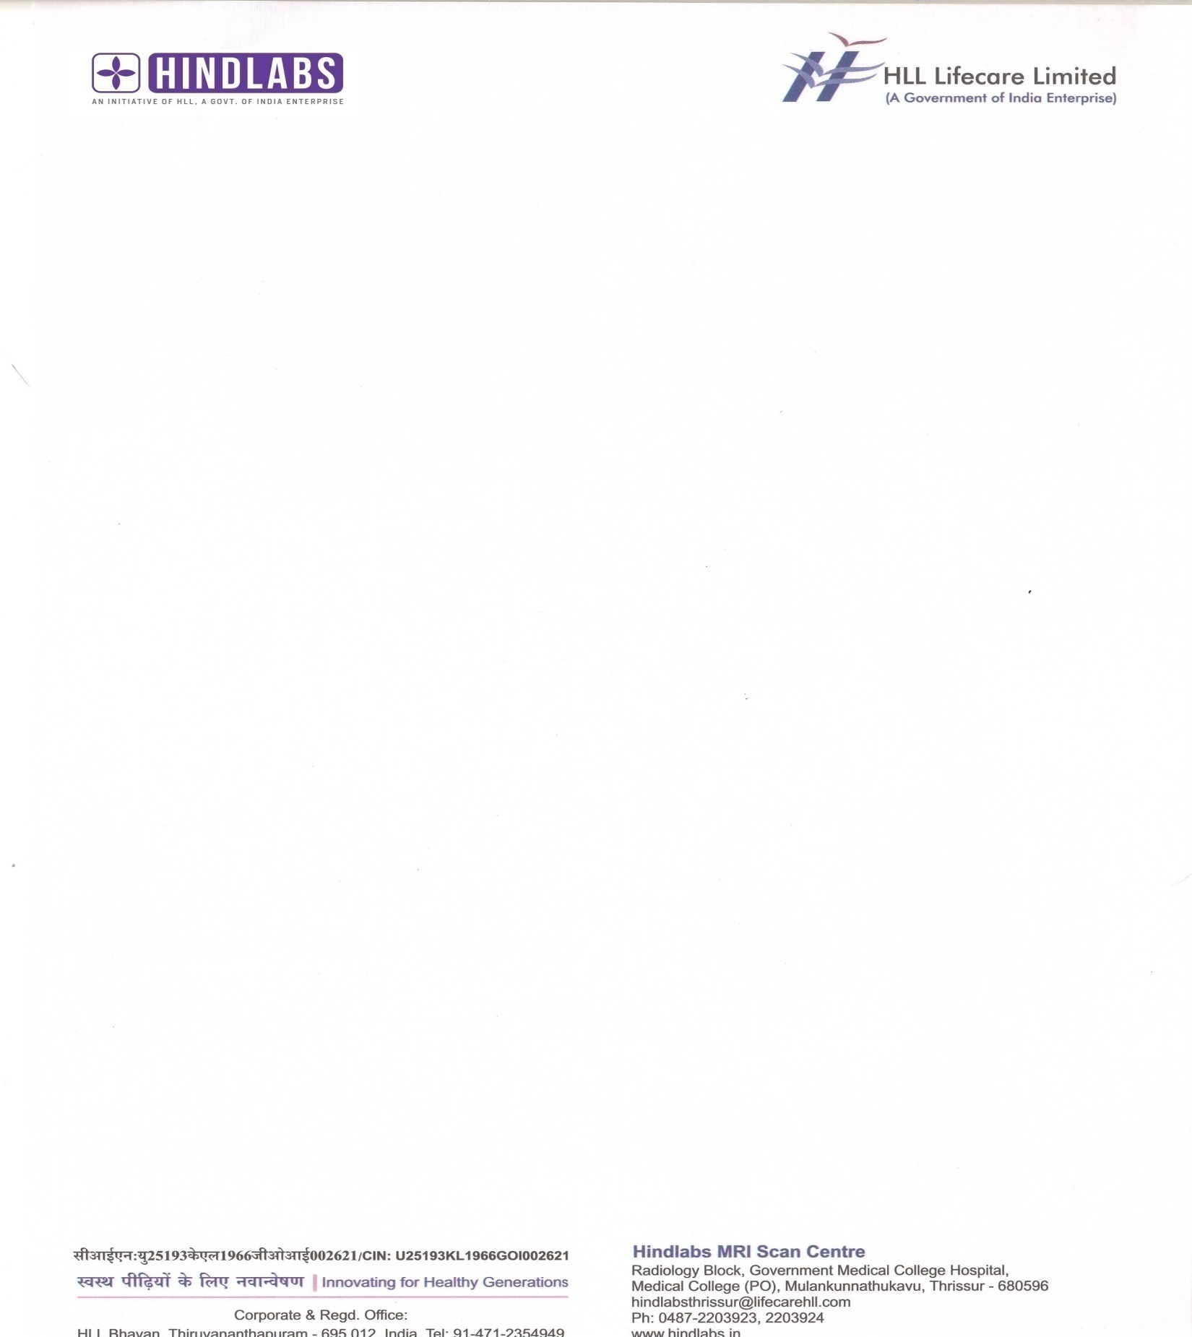

Alapuzha
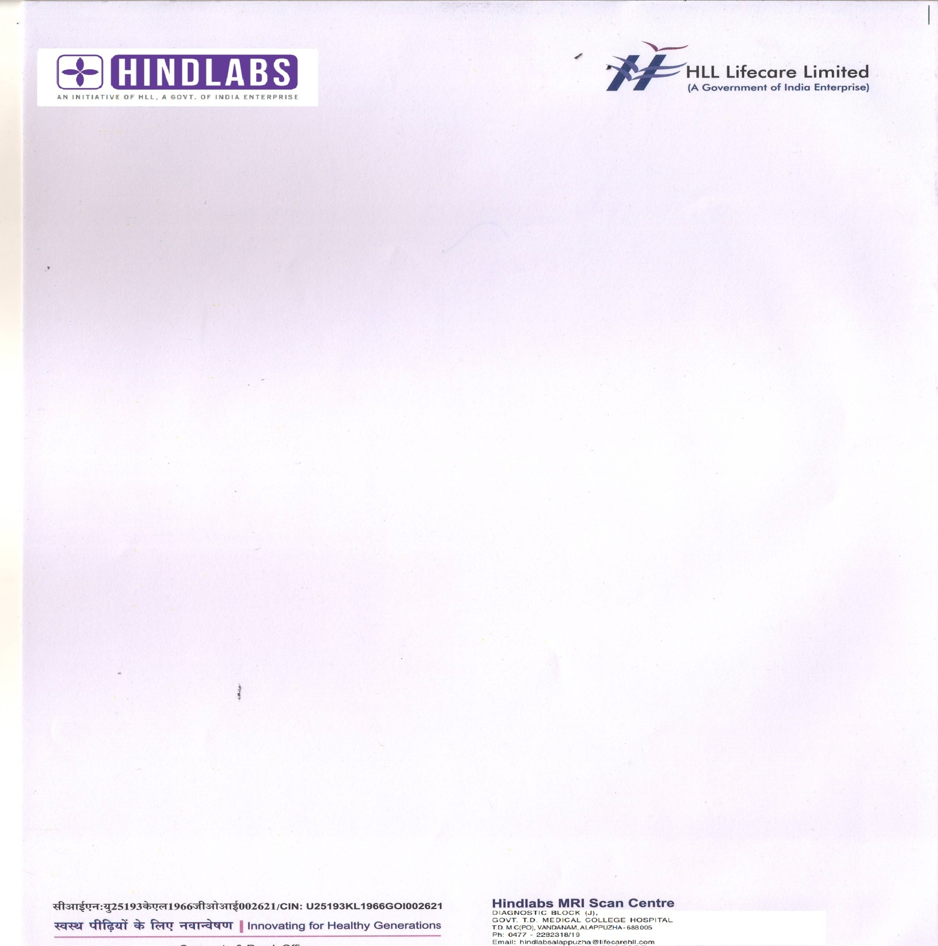

Calicut
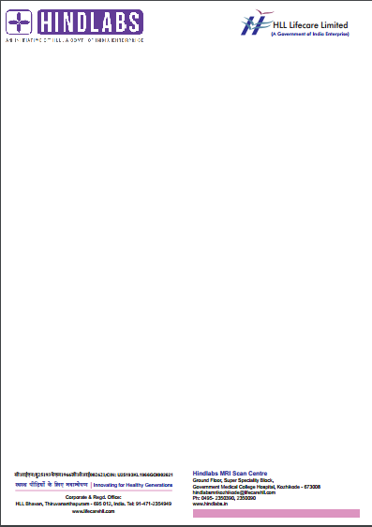

Trivandrum CT

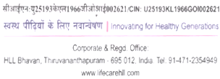
Hindlabs CT Scan Centre
Govt. Medical College Hospital
Thiruvananthapuram

Trivandrum Diagnostics and Polyclinic Centre, Trida

Hindlabs Diagnostic Centre & Polyclinic
Opposite Govt. Medical College, Trida Sopanam Complex
Thiruvananthapuram, Pin: 695011
Ph: 0471 – 2443445, 2443446, 9400027969

Visiting Card:
Kottayam
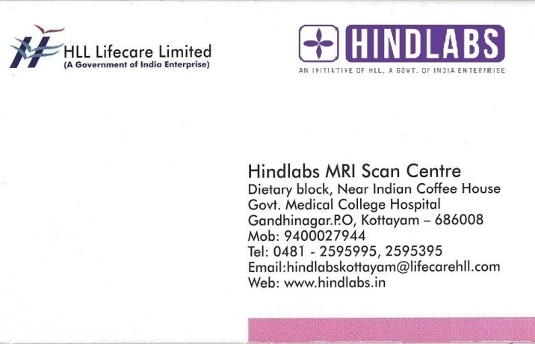
Alapuzha
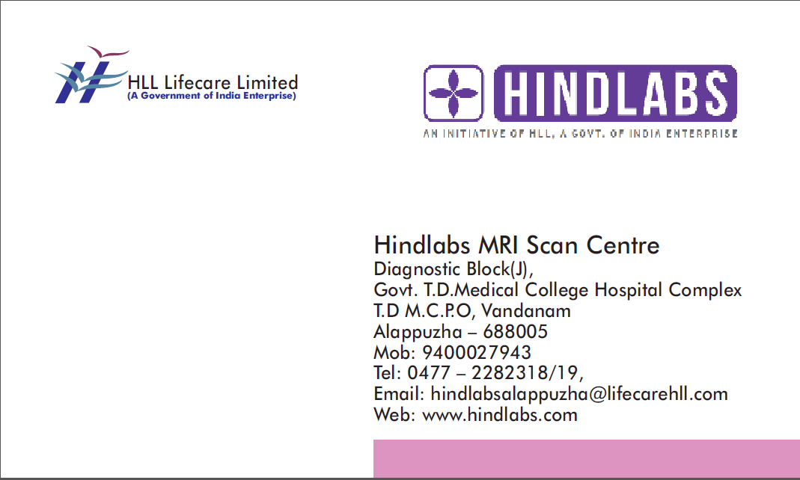
Thrissur
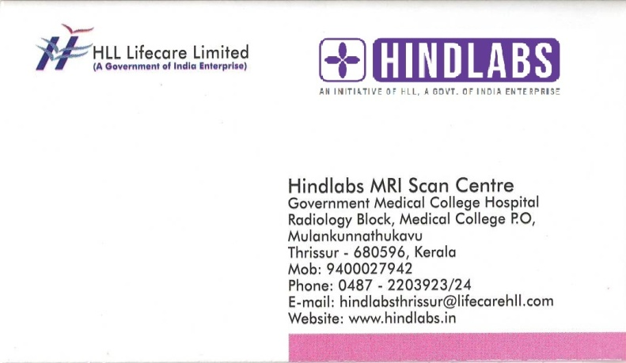

Calicut
