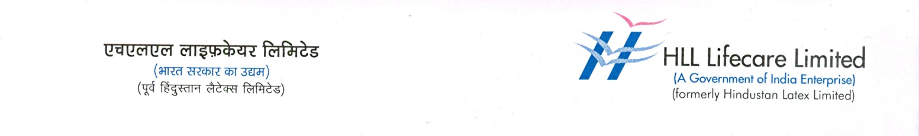

Press Release
24 July 2024
HLL invites applications
for Pratheeksha scholarships 2023-24

Thiruvananthapuram: HLL Lifecare Limited’s Pratheeksha Charitable Society has invited applications for scholarships from academically outstanding students seeking admissions in professional and technical courses for the 2023-24 academic year. Pratheeksha Charitable Society is HLL’s CSR initiative for students belonging to the BPL category.

The scheme offers financial assistance to those pursuing Medicine (MBBS), Engineering, Pharmacy, Diploma, Nursing and ITI courses, mainly open to students from Thiruvananthapuram district of Kerala studying at any educational institution within Kerala and also to students from Belgaum in Karnataka, studying at any educational institution within Karnataka respectively.

Five students will be selected from each course, and an annual grant of Rs. 40,000 will be given to students seeking scholarships for the MBBS course. In the absence of eligible MBBS students, BDS, BHMS, and BAMS students will be considered for the scholarship, and the amount will be Rs. 25,000. Pharmacy students will receive Rs. 25,000, Engineering students Rs. 20,000, Diploma and Nursing students Rs. 15,000, and students pursuing ITI will receive Rs. 5,000 annually within the course duration until they complete their courses successfully.

Under the Pratheeksha Charity initiative which was launched in 2014, HLL provided financial assistance worth Rs.1,12,55,000/- to 293 academically outstanding students belonging to the BPL category and pursuing various professional and technical courses in Thiruvananthapuram, Kerala and Belgaum in Karnataka. Pratheeksha Charitable Society, promoted by the HLL employees is the implementing forum of Pratheeksha. Funds for the Society are raised through individual contributions of the employees and from the company’s CSR fund.

As many as 30 students of 2023-24 batch will be given grants this year along with students who were granted scholarship in the previous years.

Candidates will be selected on the basis of academic performance and financial background. Interested applicants should produce original income proof issued by the authorities concerned, along with mark sheet of 10th & 12th bonafide student certificates from the head of the institution etc. Selected candidates for scholarship are expected to submit their yearly academic performance report and marksheet to continue to avail the scheme.

Application forms are available at the offices of HLL Lifecare Limited or can be downloaded from www.lifecarehll.com. Applications should reach the office of the Senior Manager (HR), HLL Lifecare Limited, Corporate and Regd Office, HLL Bhavan, Poojapura, Thiruvananthapuram- 695 012 on or before 24.08.2024 .

Thiruvananthapuram/Belgaum students
Course | MBBS | Pharmacy | Engineering | Diploma | Nursing | ITI
No of students | 5 | 5 | 5 | 5 | 5 | 5
Scholarship Amount per head | 40,000/- | 25,000/- | 20,000/- | 15,000/- | 15,000/- | 5,000/-
Scholarship Amount per head | 25,000/-(BDS,BHMS,BAMS)

