TENDER

FOR

SUPPLY AND INSTALLATION OF FURNITURE AT

HLL, BIOMEDICAL CENTRE FOR TESTING AND CALIBRATION AT CORPORATE R&D CENTRE, AKKULAM

THIRUVANANTHAPURAM

Tender No- HLL /BME/CTC/Furniture-01/14-15
August 2014

BY
HLL Lifecare Limited
(A GOVERNMENT OF INDIA ENTERPRISE)
Dept of Biomedical Engineering,
Tenra-22, Palathinkara,
TC 24/606, Thycaud,
Thiruvananthapuram-695014, Kerala.
PHONE: 0471-2330447
FAX : 0471-2320407
URL: www.lifecareHLL .com
Email: ctcbme@lifecareHLL .com

HLL LIFECARE LIMITED
(A Government of India Enterprise)
NOTICE INVITING TENDER

HLL /BME/Furniture-01/14-15 22.01.2014
Name of Work: Supply of Furniture for HLL Biomedical Centre for Testing
and Calibration

Bids are invited for the Supply of Furniture for HLL Biomedical Centre for Testing and Calibration (HLL Lifecare Limited) at Akkulam, Thiruvananthapuram. The specification and schedule for the supply is enclosed herewith.

HLL reserves the right to cancel the tenders partially or as a whole.

The offer should be submitted in a sealed envelope superscribing “Offer for Supply of furniture”.

Last date and time of Receipt of offers : 16.09.2014 2.00 pm.
Date and time of Opening of Offers : 17.09.2014 2.30 pm.

Address to which the offers are to be submitted:
Chief Biomedical Consultant
For CEO, HITES
Tenra-22, Palathinkara,
TC 24/606, Thycaud,
Thiruvananthapuram-695014, Kerala.
PHONE: 0471-2330447
Fax : 0471 2320407

Payment terms

- 80% payment on supply of the materials at site after inspection by HLL Engineers.

- 20% after 1 week of satisfactory service as certified by HLL.

The address to which the furniture to be supplied is as follows:

HLL Lifecare Limited,
CORPORATE R&D CENTRE, AKKULAM
Sreekariyam,Trivandrum
PIN-695017

Delivery period
The furniture shall be supplied within 3 weeks from the date of supply order.

Other Conditions

- There will be a pre dispatch inspection at your factory by HLL officials, if required.
- Guarantee/Warranty should be for 1 year from the date of final acceptance of furniture.
- The rate quoted should be inclusive of all taxes & duties and for supply of the items at HLL Biomedical Centre for Test and Calibration, Akkulam, Trivandrum.
- The offer shall be valid for one months.
- The supply should be arranged without causing obstructions to the normal working of the office.
- Earnest Money of Rs 8000/- in the form of a Demand Draft of a scheduled bank issued in favour of HLL Lifecare Limited, Thiruvananthapuram, or in the form of an irrevocable Bank guarantee of any scheduled bank or State Bank of India and its associates, which should be placed in a separate sealed cover marked “Earnest Money” shall be submitted along with the tenders.
- The earnest money shall be valid for a period of 135 days from Tender opening date.
- Unsuccessful tenderers’ earnest money will be returned to them without any interest, not later than thirty days after conclusion of the resultant contract. Successful tenderer’s earnest money will be returned without any interest, after receipt of performance security from that tenderer.
- The tenders shall remain valid for acceptance for a period of 90 days after the date of tender opening prescribed in the Tender document. Any tender valid for a shorter period shall be treated as unresponsive and rejected.
- Tenders shall be submitted to HLL Lifecare Ltd., Thycaud, Trivandrum by hand or through registered post or courier service at the address given below and not later than 14.00Hrs on 16.09.2014. In respect of Applications received by post or courier, HLL shall not assume any responsibility for any delayed delivery. Documents submitted in connection with this tender will be treated confidential.
- A tender, which is received after the specified date and time for receipt of tenders will be treated as “late” tender and will be ignored.
- The tenders will be opened at the specified date and time and at the specified place
as indicated in the Schedule for submission of Application
.
In case the specified date of tender opening falls on /is subsequently declared a holiday or closed day for the purchaser, the tenders will be opened at the appointed time and place on the next working day.

- If, in the price structure quoted by a tenderer, there is discrepancy between the unit price and the total price (which is obtained by multiplying the unit price by the quantity), the unit price shall prevail and the total price corrected accordingly, unless the purchaser feels that the tenderer has made a mistake in placing the decimal point in the unit price, in which case the total price as quoted shall prevail over the unit price and the unit price corrected accordingly.
- If there is a discrepancy between the amount expressed in words and figures, the amount in words shall prevail.
- Item-wise Evaluation: The List of Requirements contains more than one item; the responsive tenders will be evaluated and compared based on total price quoted for all items.
- The contract will be awarded to the lowest evaluated responsive tenderer decided by the purchaser.
- The purchaser and/or its nominated representative(s) will inspect and/or test the ordered goods and the related services to confirm their conformity to the contract specifications and other quality control details incorporated in the contract. The purchaser shall inform the supplier in advance, in writing, the purchaser’s programme for such inspection and, also the identity of the officials to be deputed for this purpose. The cost towards the transportation, boarding & lodging will be borne by the purchaser and/or its nominated representative(s).
- Goods shall be delivered by the supplier in accordance with the terms of delivery as follows:
The goods shall be supplied, unpacked, and installed at the HLL Biomedical centre for Testing and Calibration (HLL Lifecare Limited) at Corporate R&D centre Akkulam, Thiruvananthapuram within 3 weeks of receipt of letter of acceptance. All costs including insurance, loading, unloading etc shall be borne by the supplier.
- Warranty: The supplier warrants comprehensively that the goods supplied under the contract is new, unused and incorporate all recent improvements in design and materials unless prescribed otherwise by the purchaser in the contract. The supplier further warrants that the goods supplied under the contract shall have no defect arising from design, materials (except when the design adopted and / or the material used are as per the Purchaser’s/Consignee’s specifications) or workmanship or from any act or omission of the supplier, that may develop under normal use of the supplied goods under the conditions prevailing in India.
- This warranty shall remain valid for 2 (two) years after the goods or any portion thereof as the case may be, have been delivered to the final destination and installed and commissioned at the final destination and accepted by the Purchaser/Consignee in terms of the contract, unless specified otherwise in the SCC.
- In the event of any rectification of a defect or replacement of any defective goods during the warranty period, the warranty for the rectified/replaced goods shall be extended to a further period of twenty four (24) months from the date such rectified / replaced goods starts functioning to the satisfaction of the purchaser.
- Payment Terms:
80% against delivery at site .
20% against installation and acceptance against certificate of final inspection.

Payment shall be made subject to recoveries, if any, by way of liquidated damages or any other charges as per terms & conditions of contract and upon the submission of the following documents:
i. Four copies of supplier’s invoice showing contract number, goods description, quantity, unit price and total amount;
ii. Consignee Receipt Certificate in original issued by the authorized representative of the consignee;

- The supplier shall deliver the goods and perform the services under the contract within the time schedule specified by the Purchaser/Consignee in the List of Requirements and as incorporated in the contract.

24. Any unexcused delay by the supplier in maintaining his contractual obligations towards delivery of goods and performance of services shall render the supplier liable to any or all of the following sanctions.
(i) Imposition of liquidated damages and
(iii) Termination of the contract for default

- Liquidated damages: If the supplier fails to deliver any or all of the goods or fails to perform the services within the time frame(s) incorporated in the contract, the Purchaser/Consignee shall, without prejudice to other rights and remedies available to the Purchaser/Consignee under the contract, deduct from the contract price, as liquidated damages, a sum equivalent to 0.5% per week of delay or part thereof on delayed supply of goods and/or services until actual delivery or performance subject to a maximum of 10% of the contract price. Once the maximum is reached, Purchaser/Consignee may consider termination of the contract.

- The contract shall be governed by and interpreted in accordance with the laws of India for the time being in force.

Chief Biomedical Consultant
For CEO, HITES
Tender inviting authority
HLL Lifecare Limited

Encl: (1) Price Shedule
(2) Detailed specification
(3) Consignee Receipt Certificate

PRICE SCHEDULE

Supply and Installation of the following Furniture. See the attached detailed specification for the following ten items.
Sl. No | Description | Qty | Unit | Rate (in figures) (Rs.) | Rate (in words) (Rs.) | Amount (Rs.)
1 | Work table | 2 | Nos
2 | Chair | 14 | Nos
3 | Revolving stool | 4 | Nos
4 | Executive chair | 2 | Nos
5 | Executive table | 2 | Nos
6 | Conference table | 1 | Nos
7 | Computer table | 2 | Nos
8 | Office table | 1 | Nos
9 | Almirah (with powder coating) | 4 | Nos
10 | File rack (with powder coating) | 1

Total tender price in rupees________________________________________________________________

In words: _____________________________________________________________________________________________________

Note: 1) The rate quoted shall be inclusive of all taxes and duties, transportation charges, insurance charges valid till installation and commissioning, loading and unloading charges etc.

2) If there is a discrepancy between the rate in figures and words the rate in words shall prevail.

Name________________________
Business Address________________________
Place: __________________________ Signature of Tenderer_____________________
Date: _________________________ Seal of the Tenderer________________________

ITEMS
Sl No | Description of the Items | Qty
1 | Work table | 2
2 | Chair | 14
3 | Revolving stool | 4
4 | Executive chair | 2
5 | Executive table | 2
6 | Conference table | 1
7 | Computer table | 2
8 | Office table | 1
9 | Almirah (with powder coating) | 4
10 | File rack (with powder coating) | 1

Detailed Specification

Item No 1
Worktable
 | Work Table-Specification (Qty 2 nos) | Compliance  Yes/No
a | Wooden Lab worktable
b | Table top should be of hard work(teak, anjili , Jack wood)
c | Should have 15A multi socket: 6 Nos (Havel, Le’grande type) fixed.
e | Finishing should be marine plywood, painted after putty applied.
f | Should have 2 drawers and one storage shelves with 4 compartments.
g | External Dimension: 140cmLx75cmWx100cmH
h | A typical drawing with dimension is attached

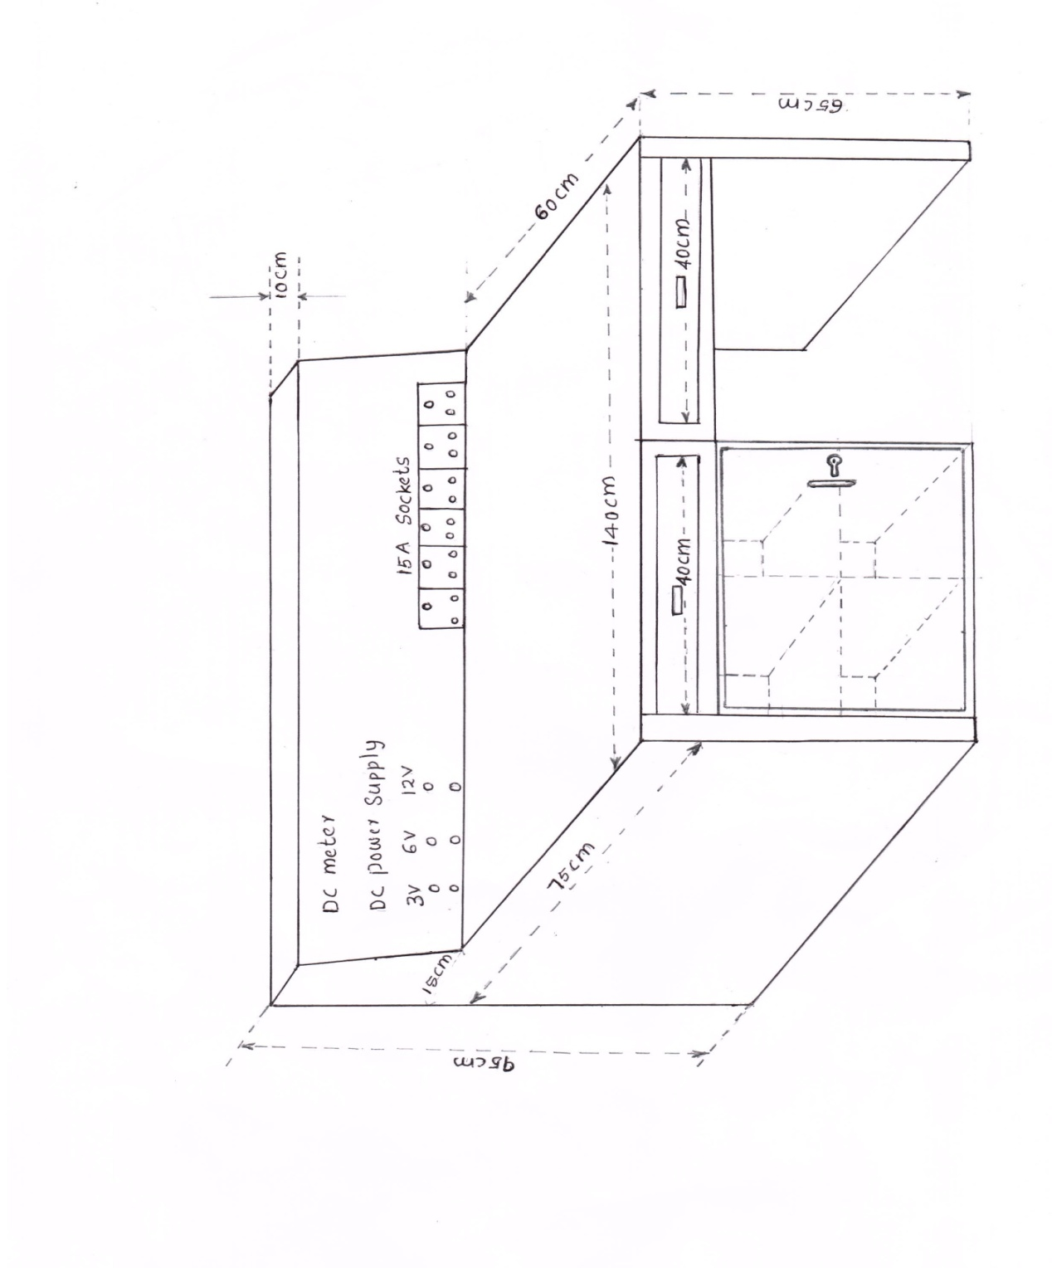

Item No 2

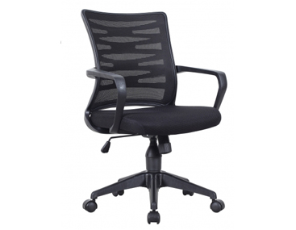

 | Chair- Specification | Compliance  Yes/No | Remarks
a | SEAT/BACK ASSEMBLY: The seat is made up of 1.2cm. thick hot-pressed plywood, upholstered with pure leather (Black) at body contact areas and polyurethane foam. The back is made up of Dia 10mm M.S tubular frame, upholstered with pure leather (Black) at body contact areas.
b | POLYURETHANE FOAM: The polyurethane foam for the seat is of density = 32 ±2 kg/cu.m and for the back is of density = 24 ±2 kg/cu.m.
c | ARMRESTS (ADJUSTABLE): The armrest top is soft touch upholstered with pure leather mounted on to an injection moulded height adjustable type armrest.
d | LEG FRAME ASSEMBLY (9N12AX): Leg frame welded assembly is made from 38mm X 19mm X 1.2mm elliptical MS ERW tube with base plate for seat fixing. 95.5HEIGHT (H), 75 DEPTH (D), 75WIDTH (W), 44 SEAT HEIGHT (SH).
e | Revolving type

Item No 3

 | Revolving Stool- Specification | Compliance  Yes/No | Remarks
a | SEAT ASSEMBLY: The seat is made up of 1.2 cm thick Commercial Grade plywood with moulded Polyurethane foam and are upholstered with replaceable fabric covers. The upholstery is available in Leather cloth and Fabric.  SEAT SIZE: Diameter 40.0 cm  ADJUSTMENTS: 360 Degree Revolving type
b | BACK ASSEMBLY : The back foam is designed with contoured Lumbar support for extra comfort. The upholstery is available in Leather cloth and Fabric.  BACK SIZE: 45.0 cm (W) covered with U foam.
c | POLYURETHANE FOAM: The polyurethane foam is moulded with density = 45 +/-2 kg/m3 and Hardness 20 +/- 2 on Hampden machine at 25% compression.
d | HEIGHT ADJUSTMENT: The manual height adjustment is very easy to operate with a help of a knob. It can be easily locked at the most comfortable position.
e | PEDESTAL ASSEMBLY : The five-prong pedestal is fabricated from 0.2cm. Thick CR steel, powder coated and fitted with an injection moulded black Polypropylene Hub Cap and 5 nos. twin wheel castors (Castor wheel diameter 5.0cm.). The pedestal is 55.0cm pitch-circle diameter (65.0 cm with Castors).
f | TWIN WHEEL CASTORS: The twin wheel castors are injection moulded in Black Nylon.

Item No 4
 | Executive Chair –specification | Compliance  Yes/No | Remarks
a | 1) SEAT/BACK ASSEMBLY: The seat is made up of 1.2cm. thick hot-pressed plywood, upholstered withpure leather (Black) at body contact areas and polyurethane foam. The back is made up of Dia 10mm M.S tubular frame, upholstered with pure leather (Black) at body contact areas.
b | 2) POLYURETHANE FOAM: The polyurethane foam for the seat is of density = 32 ±2 kg/cu.m and for the back is of density = 24 ±2 kg/cu.m.
c | 3) ARMRESTS (ADJUSTABLE): The armrest top is soft touch upholstered with pure leather mounted on toan injection moulded height adjustable type armrest.
d | 4) SYNCHRO MECHANISM: The mechanism is designed with the following features: 360 degree revolving type. Single point control. Tilt tension adjustment. 5-position locking with anti-shock feature
e | 5) CONNECTING SPINE BRACKET: Spine bracket is made of M.S. plate connecting the back with mechanism.
f | 6) PNEUMATIC HEIGHT ADJUSTMENT: The pneumatic height adjustment has an adjustment stroke of8.5+/-0.5 cm.
g | 7) PEDESTAL ASSEMBLY: Pedestal is made of High Pressure Die-cast Aluminum fitted with 5 nos. twin wheel nylon castors (castor wheel diameter 5.0 cm). The pedestal is of 65.0cm Pitch Center Diameter and with castors the outer dimension is 75.0 cm. 113-121 HEIGHT (H), 75DEPTH 75(D), WIDTH (W) 42.5 - 50.5, SEAT HEIGHT (SH).

Item No 5
 | Executive Table-Specification | Compliance  Yes/No | Remarks
a | Desk: Made from 25mm MDF and clad with laminate and coated  with pigmented polyurethane and SS Leg pipe
b | Pedestal Desk : Mobile pedestal with box drawers moulded on roller slides and filing drawer mounted on telescopic ball slide.  Pedestal contains 3 box drawers mounted as roller slides.
c | Desk dimension: W1800xD900xH750 mm
d | Mobile Pedestal: W 400xD 560XH 560mm

Item No 6
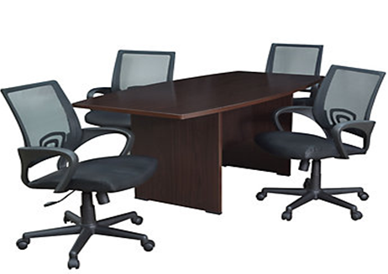

 | Conference table- Specification | Compliance  Yes/No | Remarks
a | Wooden conference table
b | Durable design, metal powder coated
c | Top made up pre laminated, ivory coloured material of high density pressed wood, properly treated.
d | Flame and water retardant. Lipped on all sides
e | Frame colour: ivory/grey
f | Size (approx):35 inch(D)X71 inch(w)x29 inch (H)

Item No 7
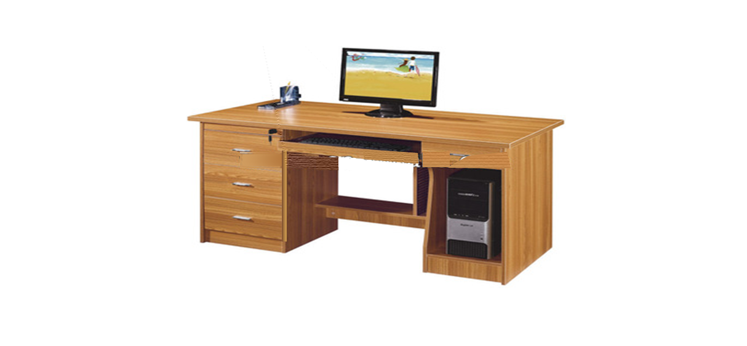

 | computer table- Specification | Compliance  Yes/No | Remarks
a | Wooden office table
b | Durable design, metal powder coated
c | Top made up pre laminated, ivory coloured material of high density pressed wood, properly treated.
d | Flame and water retardant. Lipped on all sides
e | Frame colour: ivory/grey
f | Should have an option for placing keyboard of computer
g | One shelf on left side with 2 drawers,Leg Rest
h | Size (approx):1200 mm(L)X800 mm(w)x750 mm(H)

Item 8
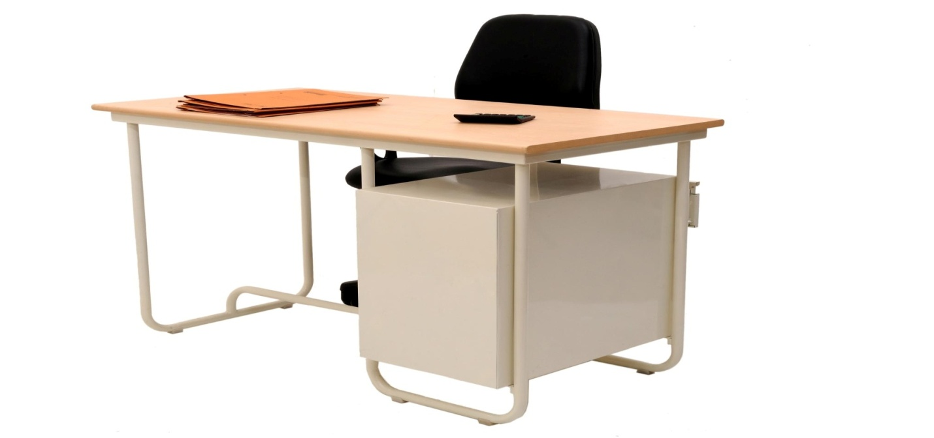

 | Office table | Compliance  Yes/No | Remarks
a | Stainless steel office table
b | Durable design, metal powder coated
c | Top made up pre laminated, ivory coloured material of high density pressed wood, properly treated.
d | Flame and water retardant. Lipped on all sides
e | Frame colour: ivory/grey
f | One shelf on left side with 3 drawers with door
g | Size (approx):1200 mm(L)X800 mm(w)x750 mm(H)

Item No 9
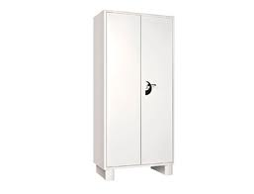
 | Almirah –Specification | Compliance  Yes/No | Remarks
a | 18 gauge steel wardrobe with lock & key
b | made of 1.25 mm CRCA (Cold Rolled Close Annealed) Steel powder coated
c | 4 adjustable shelves
d | Width: 900 , Depth: 500 , Height: 2000 approx

Item No 10
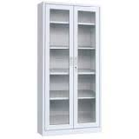
Attachment 10.a
 | File rack-Specification | Compliance  Yes/No
a | 18 gauge steel wardrobe with lock & key
b | made of 1.25 mm CRCA (Cold Rolled Close Annealed) Steel powder coated
c | 4 adjustable shelves
d | Width: 900 , Depth: 500 , Height: 2000 approx
e | With glass door for keeping books,files etc. enable to access easily.

CONSIGNEE RECEIPT CERTIFICATE
(To be given by consignee’s authorized representative)

The following store (s) has/have been received in good condition:
- Contract No. & date :______________________________
- Supplier’s Name :______________________________
- Consignee’s Name & Address with telephone No. & Fax No. : ______________________________
- Name of the item supplied :______________________________
- Quantity Supplied :______________________________
- Date of Receipt by the Consignee :______________________________
- Name and designation of Authorized Representative of Consignee :______________________________
- Signature of Authorized Representative of Consignee with date :______________________________
- Seal of the Consignee : ______________________________

