Press Release
16 June 2023

IOCL & HMA organises 'Swasthya' - Aneamia Control Programme
Kochi : In a significant effort to address the prevailing issue of anaemia among women of reproductive age, Indian Oil Corporation Limited (IOCL) has launched a groundbreaking Corporate Social Responsibility (CSR) project called 'Swasthya’ through HLL Management Academy (HMA) a educational and social development initiative of HLL Lifecare Limited (HLL), the Miniratna CPSU under the Ministry of Health and Family Welfare, Government of India. The initiative was inaugurated on 11 June 2023 by Managing Director of Kochi Metro Rail Ltd, Shri. Loknath Behera at JLN Stadium Metro Station as part of KMRL’s 6th anniversary celebration.
As part of the initiative, Anaemia detection desks is being set up in Metro stations namely, Aluva, Edapally, JLN Stadium, Ernakulam South in Kochi. The detection desk helps women passengers to undergo quick and convenient anaemia screening. This proactive approach aims to identify cases of anaemia at an early stage and provide timely intervention and support to those affected.
'Swasthya' also aims to raise awareness about anaemia, its causes, and the significance of proper nutrition among women, especially in reproductive age.
Benefiting about 10000 beneficiaries in Ernakulam district alone, 'Swasthya' had already covered more than 1000 beneficiaries. HMA's expertise in Social development initiatives have helped in the successful implementation of this women empowering 'Swasthya project'
Picture 1: IOCL CSR funded project SWASTHYA- anaemia detection desk inauguration at JLN Stadium Metro Station by Shri Loknath Behera as part of KMRL 6th anniversary celebration
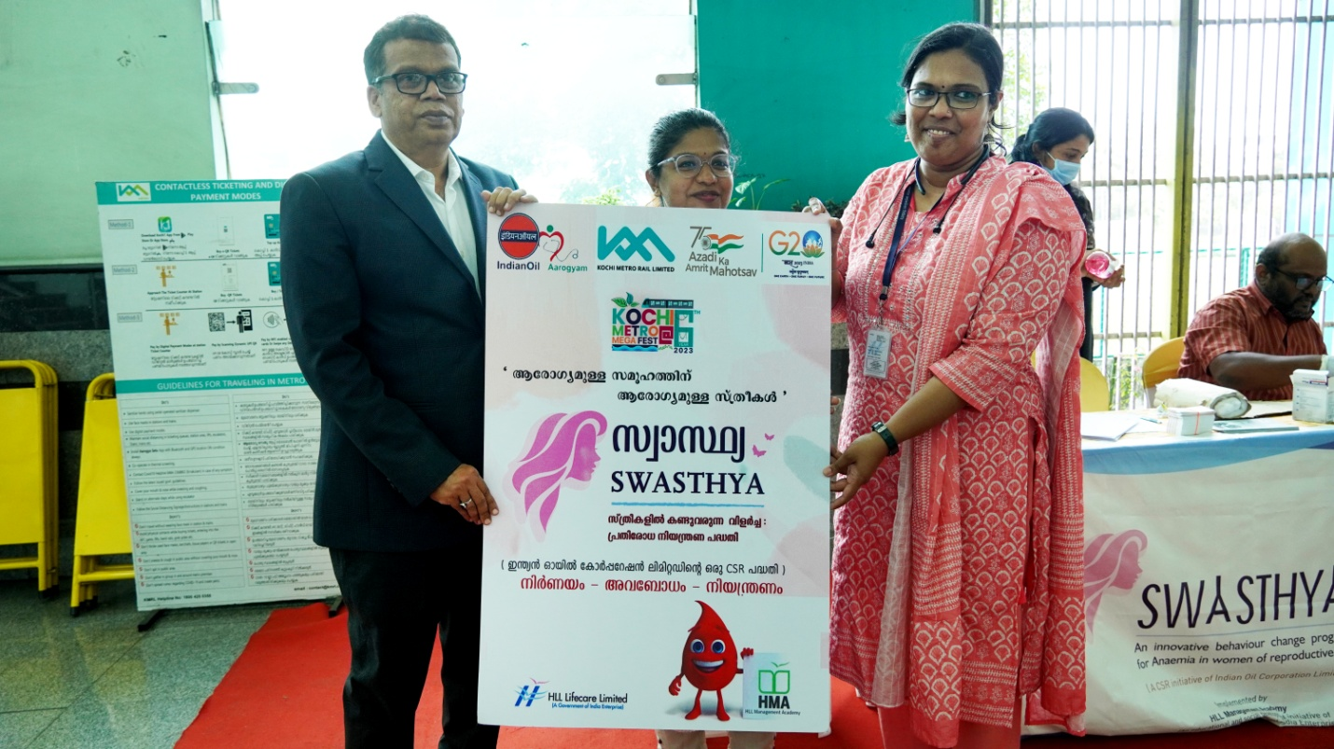
Photo Caption : Shri. Loknath Behera, Managing Director of Kochi Metro Rail Ltd, launching IOCL- HMA Swasthya programme.

